**Full Stack Development with MERN**

**Project Documentation format**

**1. Introduction**

* **Project Title:** NEXUS LEARN ONLINE
* **Team Members:**

Team Leader: - P. Yatindra Sathvik - 22BCE20260 (front-end lead)

Team Members: - D.V. Shanmukha Kumar – 22BCE20310 (back-end lead)

G. Sudheer - 22BCE20264 (front-end, documentation)

D.S.S. Sashank - 22BCE20428 (back-end, documentation)

**2. Project Overview**

**Purpose:**

"The primary objective of developing an online learning platform using the MERN (MongoDB, Express.js, React.js, Node.js) stack is to create a robust and feature-rich digital environment that facilitates effective teaching and learning experiences over the internet. This platform aims to cater to the diverse needs of students, instructors, and administrators by offering a comprehensive set of tools and functionalities.

At its core, the platform provides user authentication and authorization mechanisms to ensure secure access for all users. It enables instructors to create and manage courses efficiently, incorporating multimedia content such as videos, presentations, and interactive quizzes. Students can enroll in courses, access learning materials, submit assignments, and participate in discussions or forums facilitated by real-time messaging features.

The use of MongoDB as the database allows for flexible and scalable data storage, while Express.js provides a robust framework for building the backend server logic. React.js, renowned for its component-based architecture and efficient rendering, serves as the frontend framework to deliver a responsive and intuitive user interface. Node.js powers the server-side operations, ensuring seamless communication between the frontend and backend components.

Key features of the platform include analytics dashboards that track student progress and performance metrics, which help instructors tailor their teaching methods and content delivery strategies. Additionally, the platform may incorporate features like notifications for course updates, calendar integration for scheduling classes and assignments, and integration with payment gateways for handling course fees.

By leveraging the MERN stack's collective strengths—MongoDB's flexibility, Express.js' middleware capabilities, React.js' dynamic UI components, and Node.js' asynchronous event-driven architecture—the project aims to achieve scalability, performance, and maintainability. Ultimately, the goal is to provide a modern and engaging online learning experience that supports educational institutions, corporate training programs, and individual learners in achieving their academic and professional goals."

* **Features:**

1. User Authentication and Authorization:

- Secure login and registration processes for students, instructors, and administrators.

- Role-based access control to manage permissions for different user types.

2. Course Management:

- Instructor tools for creating, editing, and managing courses.

- Support for multimedia content such as videos, presentations, and documents.

- Course categorization and search functionalities.

3. Learning Material Delivery:

- Content delivery mechanisms for lectures, assignments, quizzes, and supplementary materials.

- Progress tracking for students to monitor completion status.

4. Communication and Collaboration:

- Real-time messaging and discussion forums for interaction between students and instructors.

- Announcement and notification systems for course updates, deadlines, and important information.

5. Assessment and Feedback:

- Tools for creating and administering quizzes and assessments.

- Automated grading and feedback mechanisms.

- Instructor feedback and grading interface for student submissions.

6. Analytics and Reporting:

- Dashboards with analytics on student progress, course effectiveness, and engagement metrics.

- Reporting capabilities for administrators to generate insights and reports.

7. Social Learning Features:

- Social sharing options for courses and content.

- Integration with social media platforms for broader reach and engagement.

8. Payment Integration:

- Secure payment gateway integration for course enrollment and fee processing.

9. Mobile Compatibility:

- Responsive design and mobile-friendly interfaces for seamless access on smartphones and tablets.

10. Admin Dashboard:

- Administrative tools for managing users, courses, payments, and overall platform settings.

- Data management and backup features.

11. Accessibility and Localization:

- Support for multiple languages and accessibility features to cater to diverse user needs.

12. Security and Scalability:

- Implementation of best practices for data security, including encryption and secure connections.

- Scalable architecture to handle varying levels of user traffic and content volume.

These features collectively enhance the functionality and usability of the online learning platform, providing a comprehensive solution for educational institutions, corporate training programs, and individual learners.

**3. Architecture**

* **Frontend:**

React components for each major functionality.

State management using Redux.

Routing with React Router.

API calls to the backend

* **Backend:**

Express.js server handling API requests.

Separate routes, controllers, and models for clarity.

Middleware for authentication and error handling.

MongoDB database with Mongoose schemas

* **Database:**

MongoDB for storing user, book, and order data.

Mongoose for schema definitions and interactions.

**4. Setup Instructions**

* **Prerequisites:** Nodejs,MongoDB,React,Express
* **Installation:**

To develop a full-stack Book Store App using React js, Node.js,Express js and MongoDB, there are several prerequisites you should consider. Here are the key prerequisites for developing such an application:

**Node.js and npm:** Install Node.js, which includes npm (Node Package Manager), on your development machine. Node.js is required to run JavaScript on the server side.

• Download:<https://nodejs.org/en/download/>

• Installation instructions:<https://nodejs.org/en/download/package-manager/>

**MongoDB:** Set up a MongoDB database to store hotel and booking information. Install MongoDB locally or use a cloud-based MongoDB service.

• Download:<https://www.mongodb.com/try/download/community>

• Installation instructions:<https://docs.mongodb.com/manual/installation/>

**Express.js:** Express.js is a web application framework for Node.js. Install Express.js to handle server-side routing, middleware, and API development.

• Installation: Open your command prompt or terminal and run the following

command: **npm install express**

**React js: React** is a JavaScript library for building client-side applications.

And Creating Single Page Web-Appliaction

**5. Folder Structure**

* **Client:**

­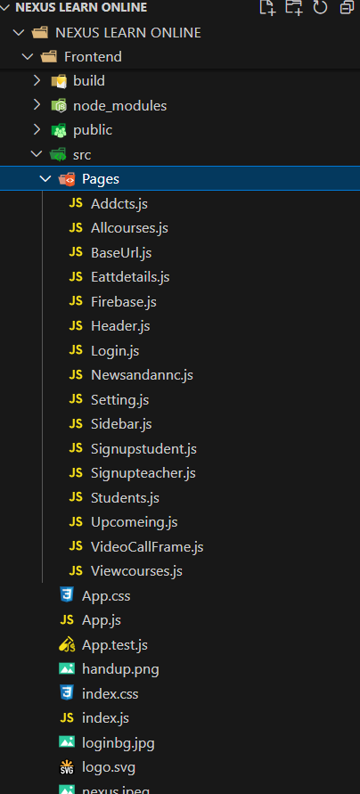

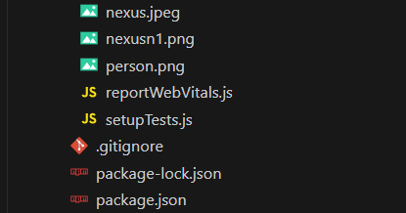

* **Server:**

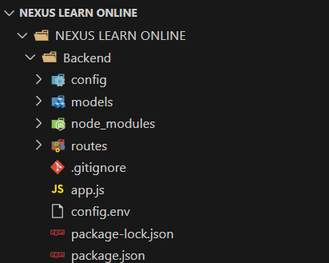

**6. Running the Application**

* Provide commands to start the frontend and backend servers locally.
  + **Frontend:** npm start in the client directory.
  + **Backend:** npm start in the server directory.

**7. API Documentation**

**User Authentication**

* **POST** /api/user/signup - Registers a new user with validation.
* **POST** /api/user/signin - Authenticates a user and returns a token.
* **GET** /api/user/signout - Signs out the user.

**User Management**

* **GET** /api/user/:userId - Retrieves user information by ID (requires authentication).
* **PUT** /api/user/:userId - Updates user information by ID (requires authentication).
* **GET** /api/users - Retrieves all users (requires admin authentication).
* **DELETE** /api/user/:userId - Deletes a user by ID (requires admin authentication).

**Course Management**

* **POST** /api/course/create - Creates a new course (requires admin or teacher authentication).
* **GET** /api/course/:courseId - Retrieves course details by ID.
* **PUT** /api/course/:courseId - Updates a course by ID (requires admin or teacher authentication).
* **DELETE** /api/course/:courseId - Deletes a course by ID (requires admin or teacher authentication).
* **GET** /api/courses - Retrieves all courses.
* **GET** /api/courses/categories - Retrieves all unique course categories.

**Section Management**

* **POST** /api/section/create - Adds a new section to a course (requires teacher authentication).
* **PUT** /api/section/:sectionId - Updates a section by ID (requires teacher authentication).
* **DELETE** /api/section/:sectionId - Deletes a section by ID (requires teacher authentication).
* **GET** /api/section/:sectionId - Retrieves section details by ID.

**Student Interactions**

* **POST** /api/enroll - Enrolls a student in a course (requires authentication).
* **GET** /api/enrollments/:studentId - Retrieves courses a student is enrolled in (requires authentication).
* **GET** /api/enrollment/:enrollmentId - Retrieves enrollment details by ID (requires authentication).
* **DELETE** /api/enrollment/:enrollmentId - Unenrolls a student from a course (requires authentication).

**Course Progress**

* **GET** /api/progress/:enrollmentId - Retrieves progress for a specific course (requires authentication).
* **PUT** /api/progress/:enrollmentId - Updates progress for a specific course (requires authentication).

**Certificates**

* **GET** /api/certificate/:enrollmentId - Retrieves a course completion certificate (requires authentication).

**Admin Functions**

* **GET** /api/admin/users - Retrieves all users (requires admin authentication).
* **GET** /api/admin/courses - Retrieves all courses (requires admin authentication).
* **GET** /api/admin/enrollments - Retrieves all student enrollments (requires admin authentication).

**8. Authentication**

1. User Registration

- User submits registration details (username, email, password).

- Backend hashes the password and stores user details in the database.

2. User Login :

- User submits login credentials (email, password).

- Backend verifies credentials, generates a JWT if valid, and sends it to the frontend.

3. Storing Token :

- Frontend stores the JWT in local storage upon successful login.

Authorization

1. Protecting Routes :

- Middleware on the backend checks for a valid token in request headers.

- Routes requiring authentication are protected using this middleware.

2. Token Verification :

- Middleware verifies the JWT and allows access to protected routes if valid.

3. Frontend Token Check :

- Frontend checks for the presence of a token in local storage to determine if the user is logged in.

4. Sending Token with Requests :

- Token is included in the Authorization header for requests to protected routes.

This architecture ensures secure and efficient handling of user authentication and authorization in your Nexus Learn Application.

**9. User Interface**

* Provide screenshots or GIFs showcasing different UI features.

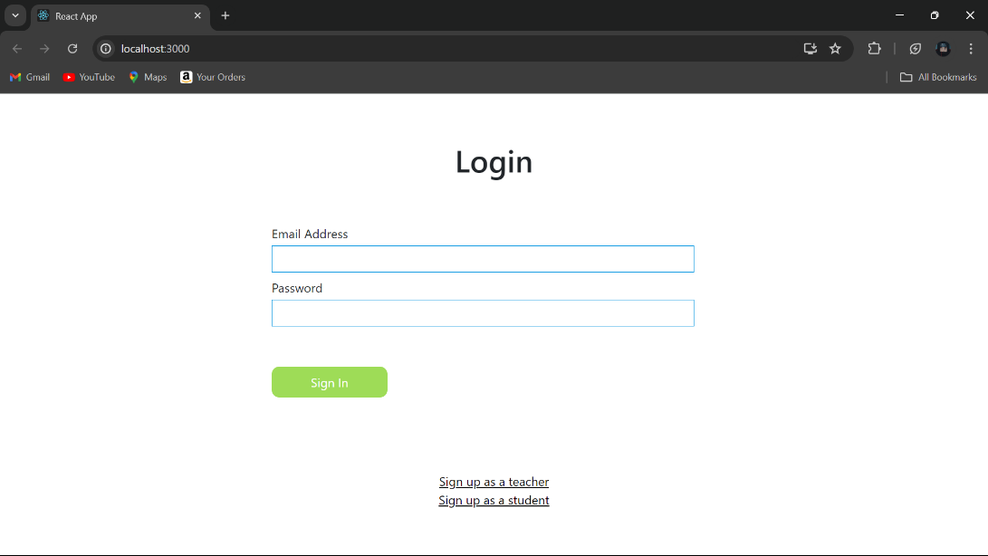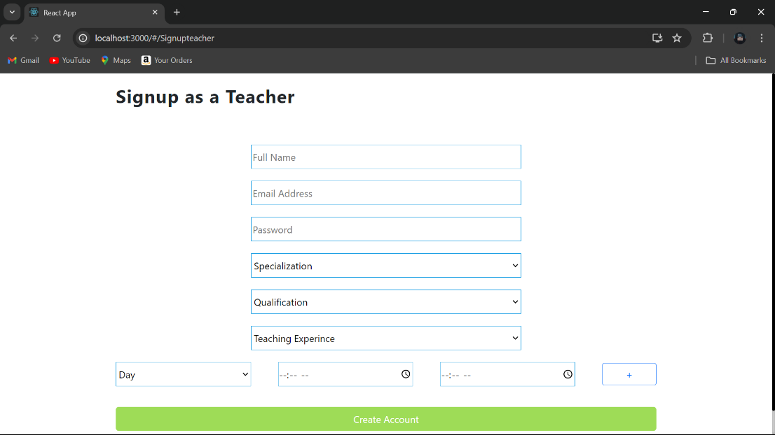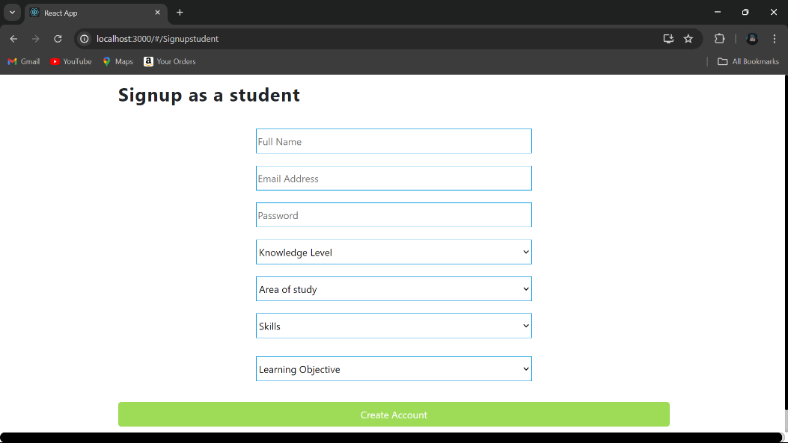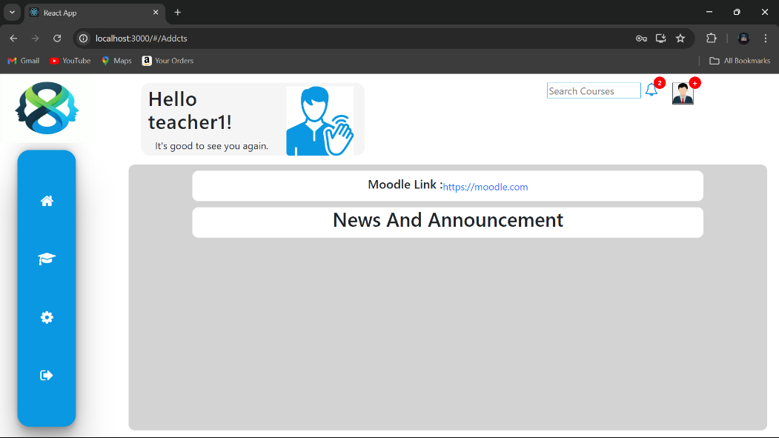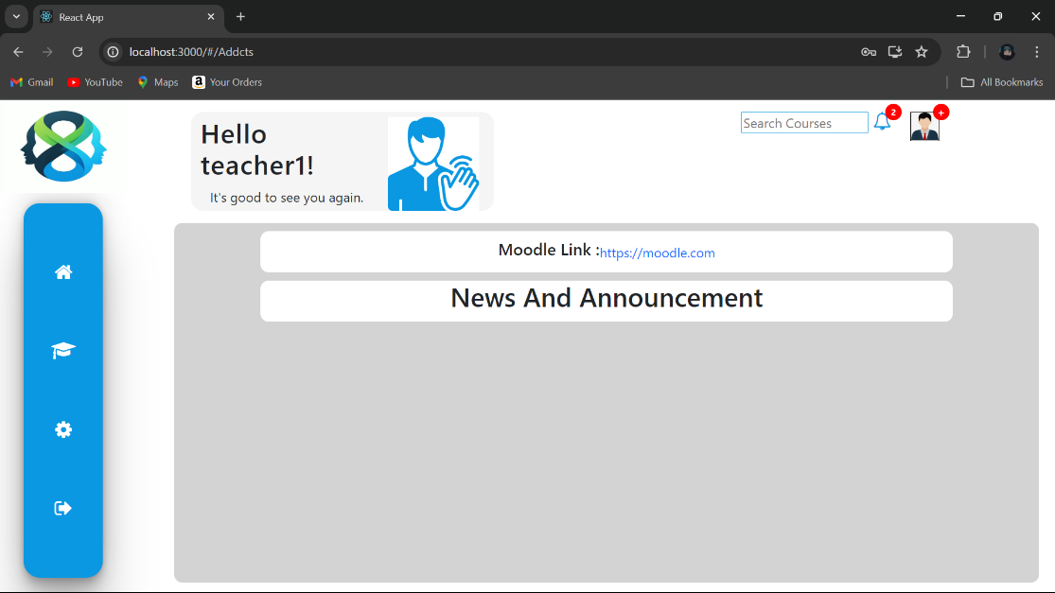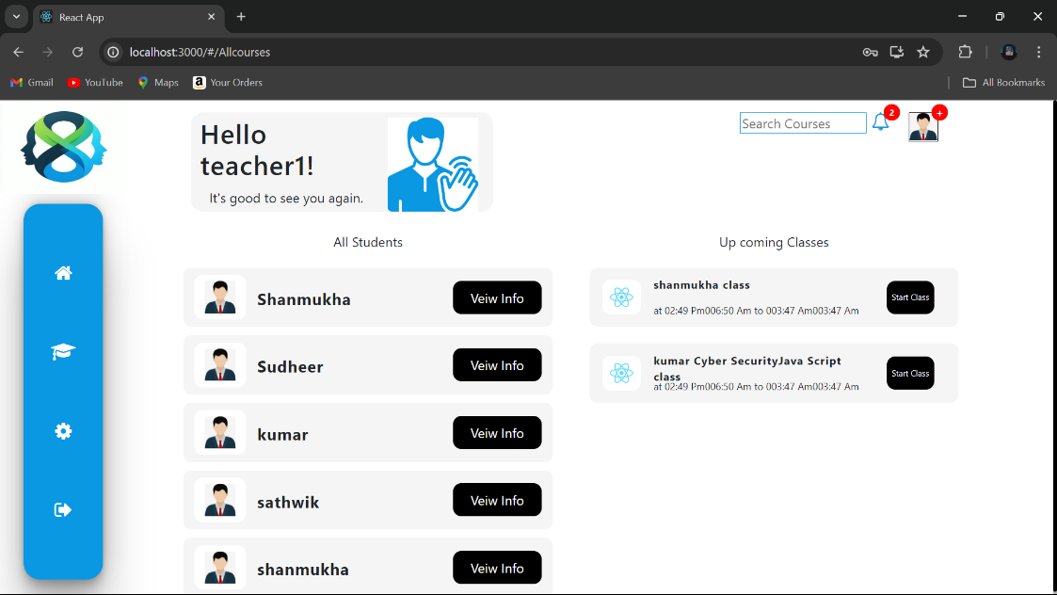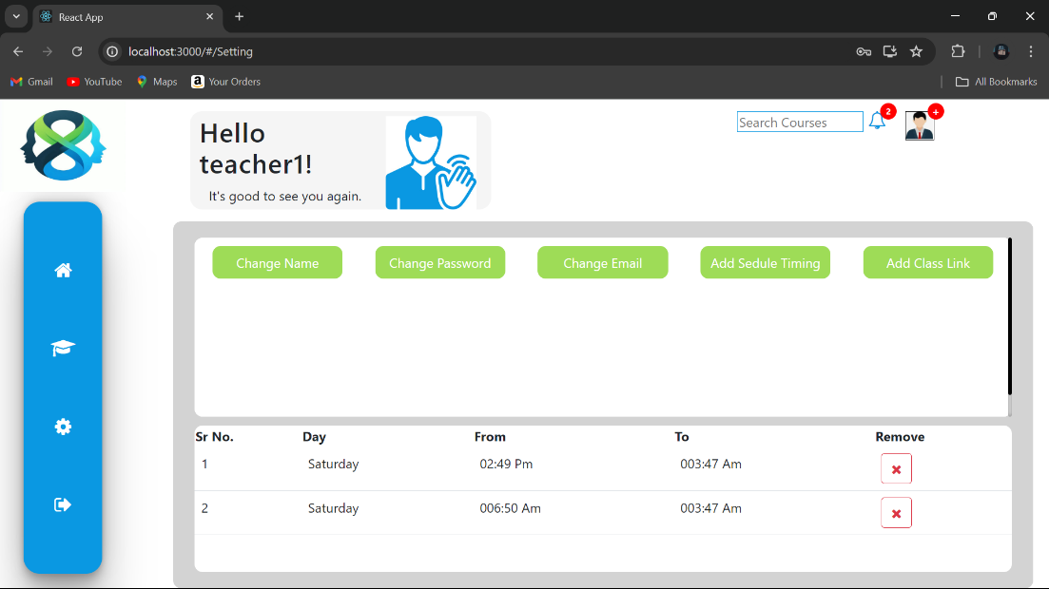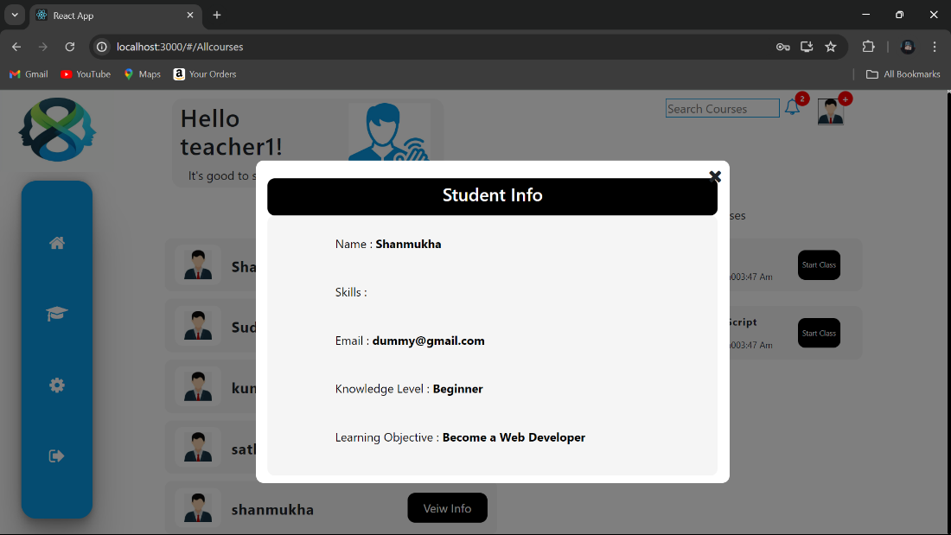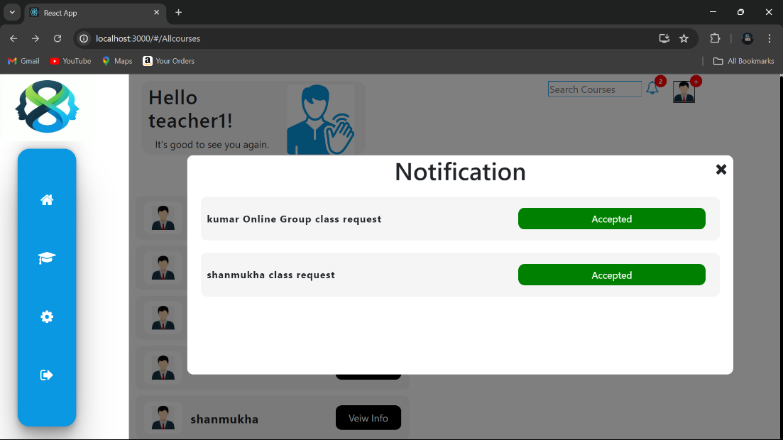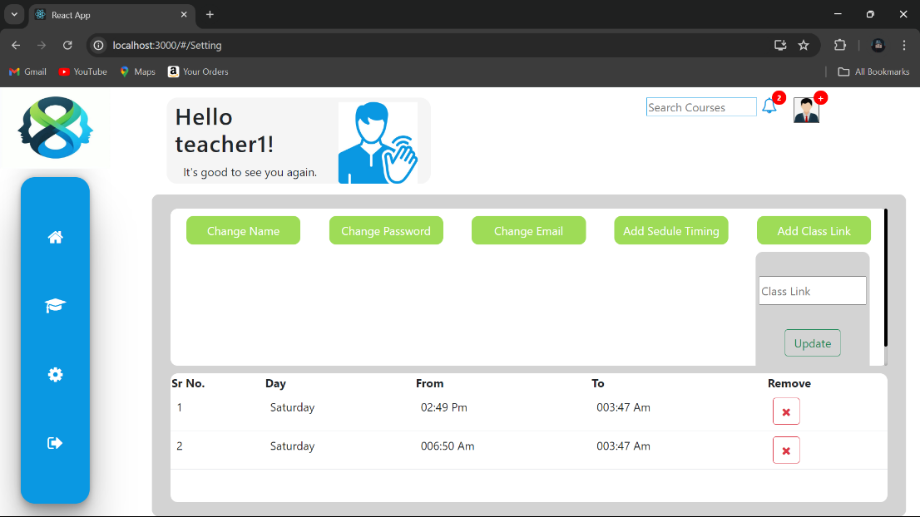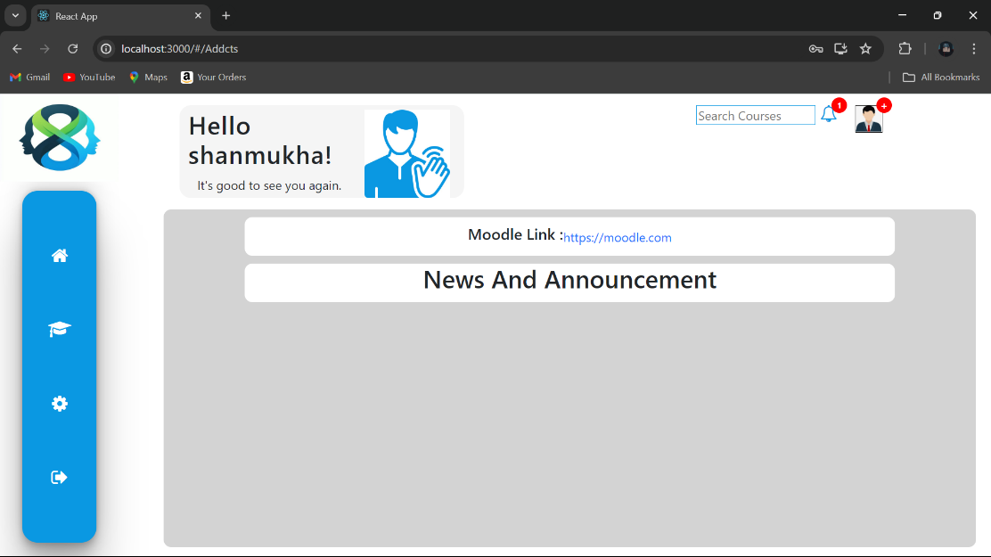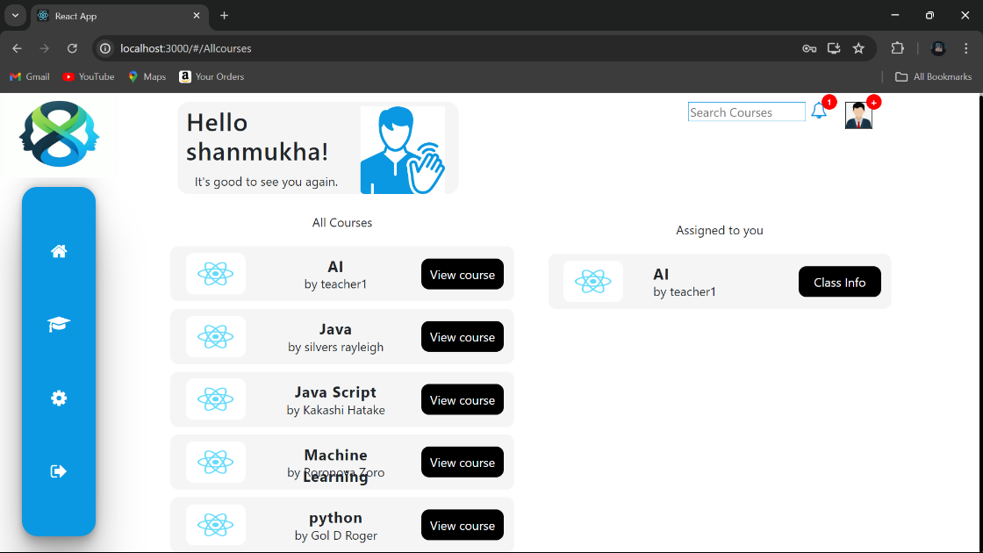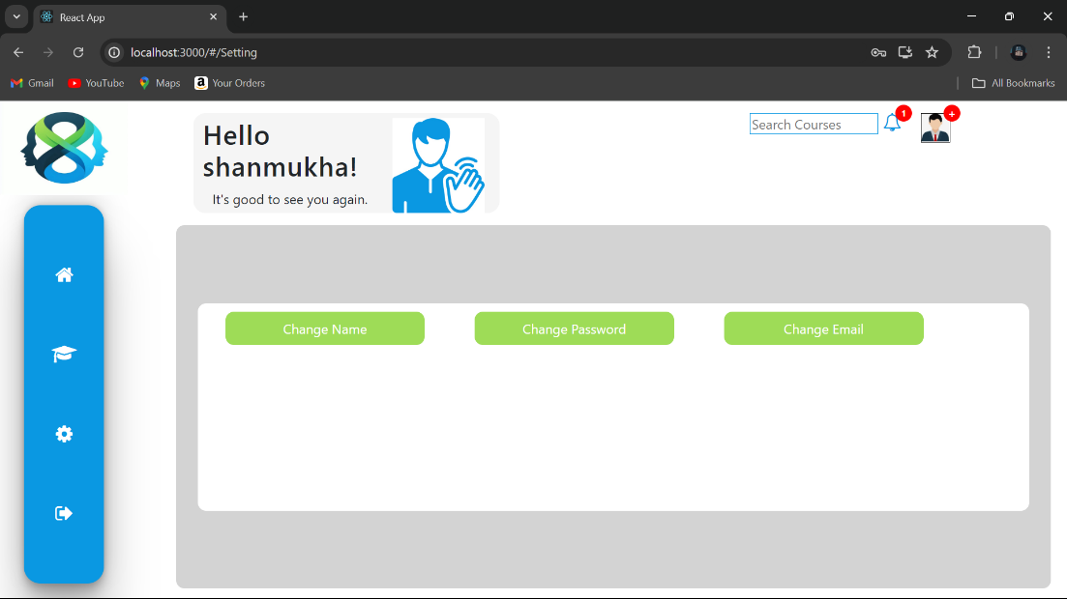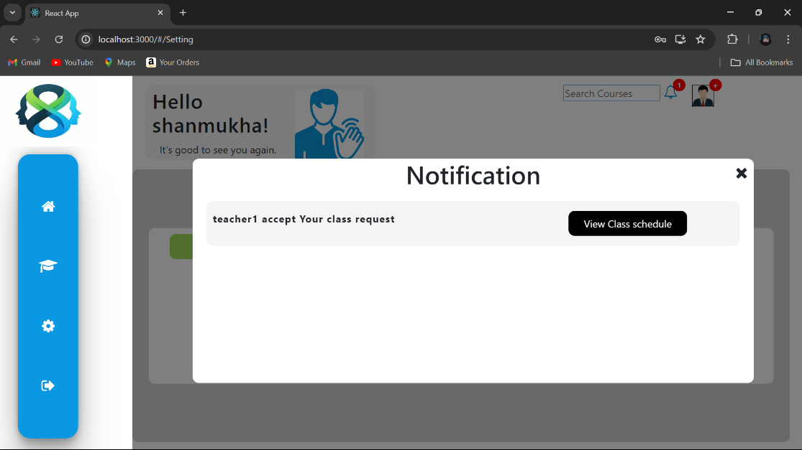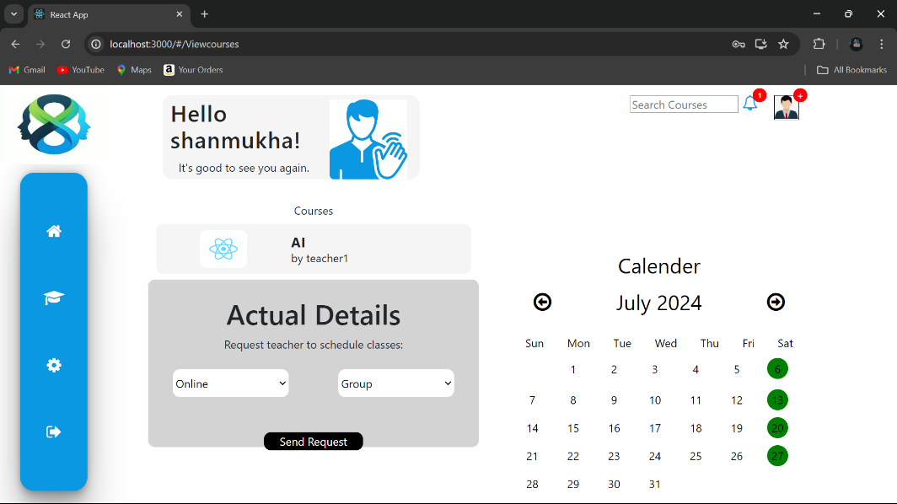

**10. Testing**

**Unit Testing:-**

- Frontend: Tested React components for rendering and functionality using Jest and React Testing Library.

- Backend: Verified backend functions and endpoints.

**Integration Testing**

- API Endpoints: Tested data flow between frontend and backend using Postman.

- Database Interactions: Verified correct CRUD operations and data integrity.

**End-to-End (E2E) Testing**

- User Scenarios: Simulated user journeys (registration, book purchase) with Cypress.

- Authentication/Authorization: Tested protected routes and token usage.

**Usability Testing**

- User Experience: Gathered feedback and made improvements based on user testing sessions.

Overall, testing ensured the application is robust, secure, and user-friendly.

**11. Screenshots or Demo**

https://drive.google.com/file/d/13mV1sicPGcerEDvdcNgqeyKcFyWkeuOZ/view?usp=drive_link

**12. Known Issues**

* No issues

**13. Future Enhancements**

Future enhancements for an "Online learning platform using MERN stack" could focus on expanding functionality, improving user experience, and integrating emerging technologies. Here are some ideas for future enhancements:

1. **Personalized Learning Paths:**
   * Implement AI-driven algorithms to analyze learner behavior and recommend personalized learning paths.
   * Offer adaptive learning experiences based on individual progress and learning styles.
2. **Virtual Reality (VR) and Augmented Reality (AR) Integration:**
   * Develop VR/AR modules for immersive learning experiences, such as virtual labs or simulations.
   * Enable real-time collaboration in virtual environments for group projects or discussions.
3. **Machine Learning for Predictive Analytics:**
   * Utilize machine learning models to predict student performance and suggest interventions for at-risk students.
   * Improve course recommendations based on learner profiles and historical data.
4. **Blockchain for Credentialing and Certification:**
   * Implement blockchain technology for secure credentialing and certification issuance.
   * Enable verifiable digital badges and micro-credentials for completed courses or skills.
5. **Gamification Elements:**
   * Introduce gamification features such as leaderboards, badges, and achievements to enhance student engagement.
   * Design interactive learning modules with game-like mechanics to make learning more enjoyable.
6. **Social Learning and Collaboration Tools:**
   * Enhance social learning capabilities with features like peer-to-peer mentoring, group projects, and collaborative editing tools.
   * Integrate social media integrations for seamless sharing and networking among learners.
7. **Advanced Analytics and Insights:**
   * Expand analytics dashboards to provide deeper insights into learner behavior, engagement patterns, and content effectiveness.
   * Incorporate predictive analytics to forecast trends and optimize course offerings.

Top of Form

Bottom of Form